# git clone https://celeguim@github.com/bitbar/devops-exercise.git

Since Chef Server, Prometheus and Grafana installation is not a requirement, so they were installed manually and configured on my own.

I have one laptop running Fedora 25 as a Host and Virtual Box running my guests; one CentOS working as the server and Ubuntu running as a Node. My laptop will act as a Workstation.

There is no firewall between them.

Added my own user to the group vboxusers, so that my user was able to link my android device to Virtual Box.

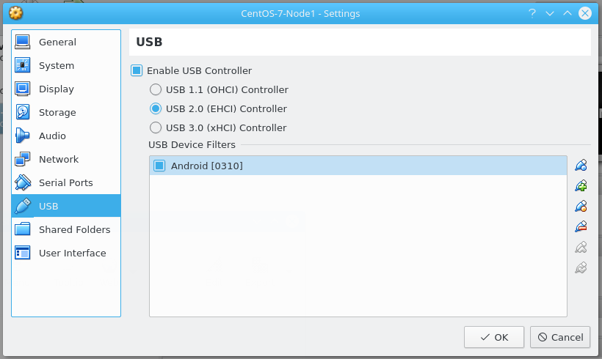

It’s necessary to install the adb bridge (android-tools) into the nodes.

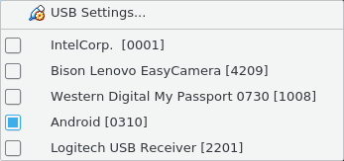

My knife.rb setup:

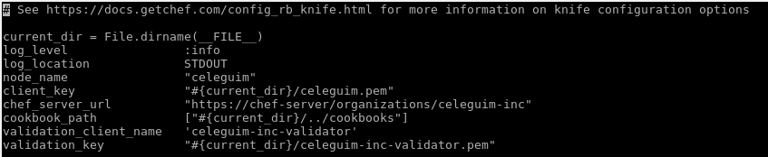

My cookbook:

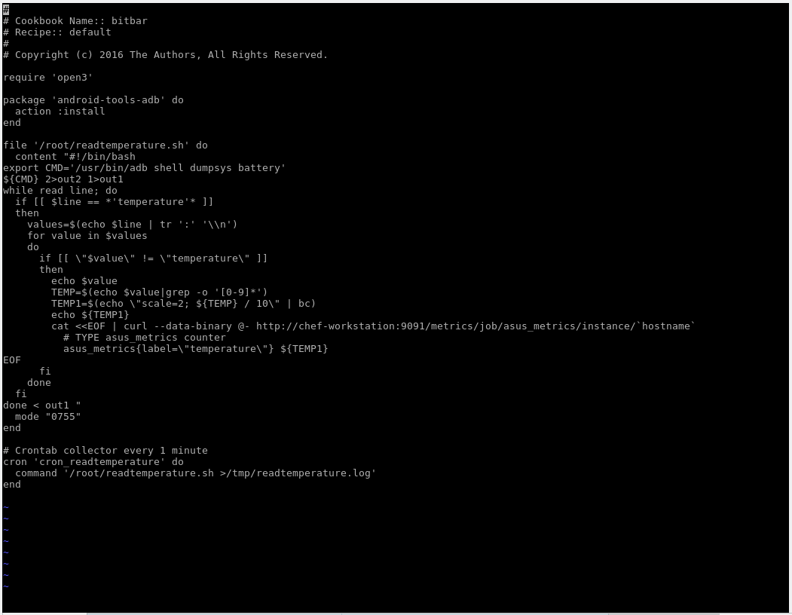

#   
# Cookbook Name:: bitbar   
# Recipe:: default   
#   
# Copyright (c) 2016 The Authors, All Rights Reserved.   
  
require 'open3'   
  
package 'android-tools-adb' do   
 action :install   
end   
  
file '/root/readtemperature.sh' do   
 content "#!/bin/bash   
export CMD='/usr/bin/adb shell dumpsys battery'   
${CMD} 2>out2 1>out1   
while read line; do   
 if [[ $line == *'temperature'* ]]   
 then   
   values=$(echo $line | tr ':' '\\n')   
   for value in $values   
   do   
     if [[ \"$value\" != \"temperature\" ]]   
     then   
       echo $value   
       TEMP=$(echo $value|grep -o '[0-9]*')   
       TEMP1=$(echo \"scale=2; ${TEMP} / 10\" | bc)   
       echo ${TEMP1}   
       cat <<EOF | curl --data-binary @- http://chef-workstation:9091/metrics/job/asus_metrics/instance/`hostname`   
         # TYPE asus_metrics counter   
         asus_metrics{label=\"temperature\"} ${TEMP1}   
EOF   
     fi   
   done   
 fi   
done < out1 "   
 mode "0755"   
end   
  
# Crontab collector every 1 minute   
cron 'cron_readtemperature' do   
 command '/root/readtemperature.sh >/tmp/readtemperature.log'   
end

The result as expected:

